41.21: a) Classically 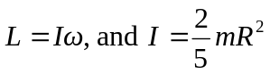 for a uniform sphere.
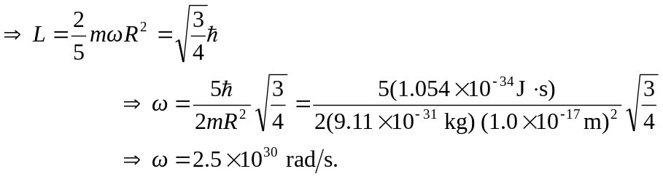
b) Since this is faster than the speed of light this model is invalid.

